NAME: KAVA DHRUVKUMAR
ROLL NO: D25CS111
PRACTICAL EXAM

Title 2: Internship Management System
Problem Definition: Develop a simple Internship Management System using HTML and PHP where users can enter details and see them reflected on the next page without using MySQL.
Features:
1. Input fields: Student Name, Company, Domain, Duration, Status.
2. On submission → show all entered data in a styled HTML table using PHP.
3. Include “Add Another Internship” button to return to the form.
4. Use CSS for table design.

XAMPP WASN’T WORKING ON PC SO EXPLAINING THE CODE AS MAM ASKED

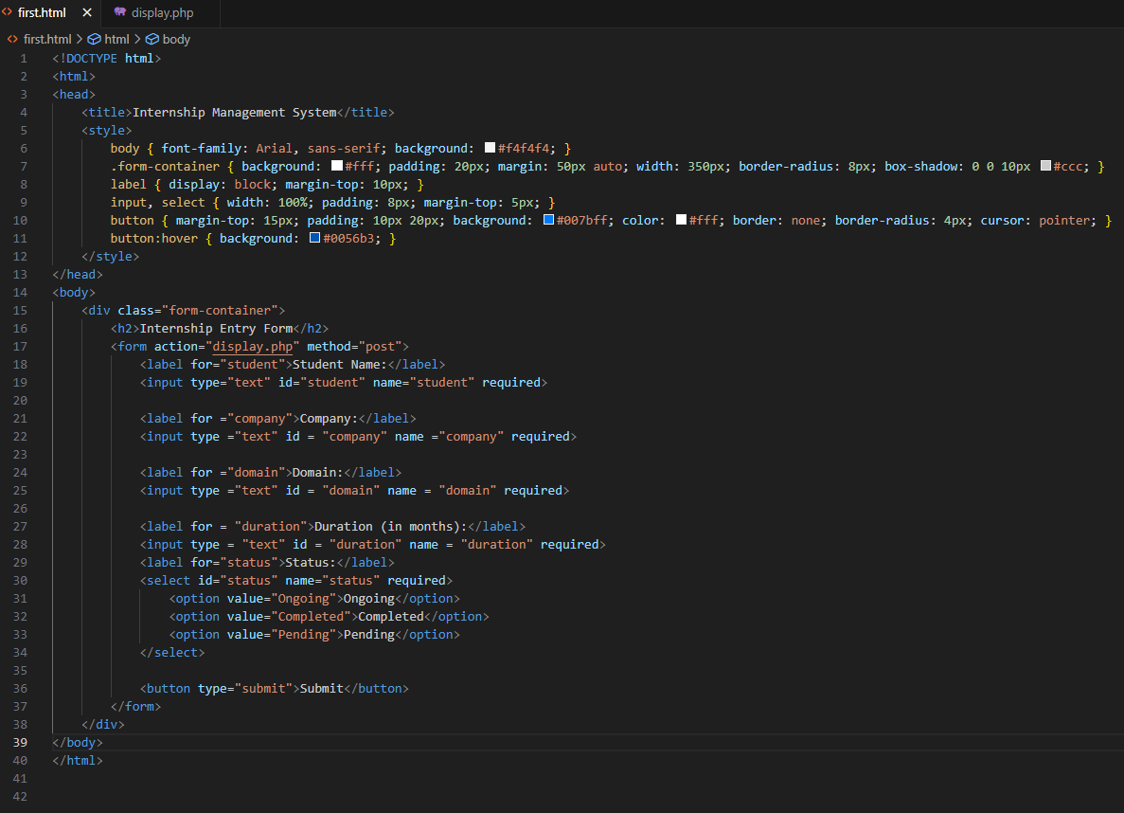

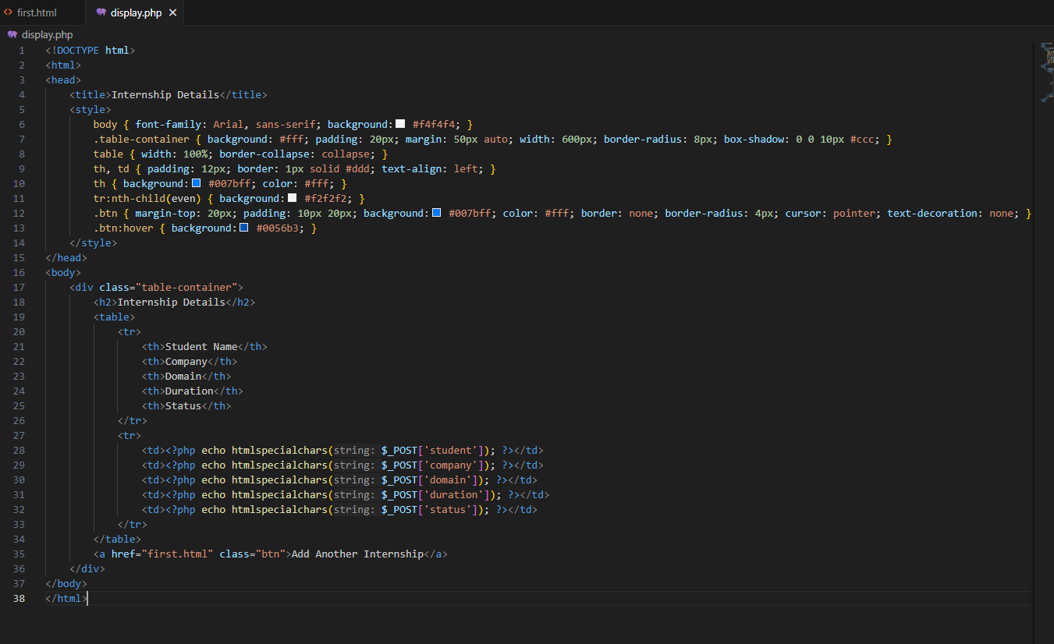

OUTPUT OF THE HTML FILE
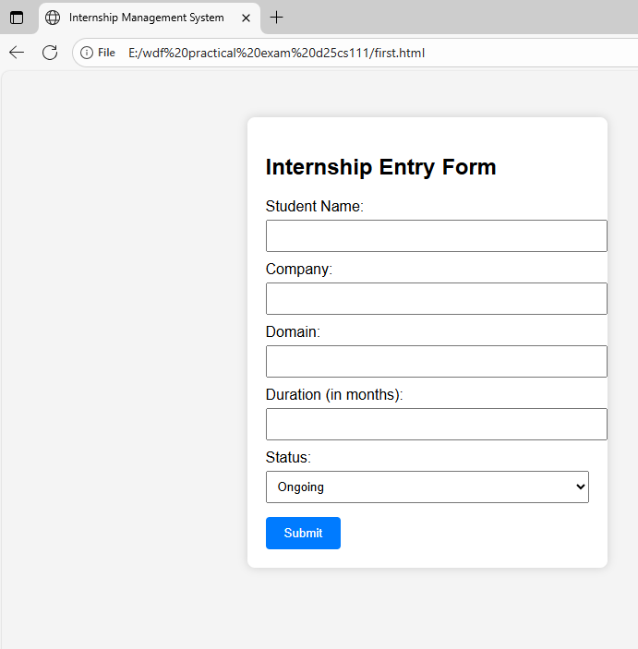

IN FIRST HTML FILE:

<html>
<head>
<title>Internship Management System</title>
<style>
body { font-family: Arial, sans-serif; background: #f4f4f4; }
.form-container { background: #fff; padding: 20px; margin: 50px auto; width: 350px; border-radius: 8px; box-shadow: 0 0 10px #ccc; }
label { display: block; margin-top: 10px; }
input, select { width: 100%; padding: 8px; margin-top: 5px; }
button { margin-top: 15px; padding: 10px 20px; background: #007bff; color: #fff; border: none; border-radius: 4px; cursor: pointer; }
button:hover { background: #0056b3; }
</style>
</head>

THIS IS CSS STYLE IN WHICH IT WILL GIVE THE CSS TO WHOLE BODY FORMAT IT WILL SET THE FONT COLOR ABD AND BACKGROUND COLOR
THEN. FORM CONTAINER WILL STYLES THE FORM BOX BACKGROUND WILL BE OF WHITE COLOR PADDING MARGIN WIDTH ROUNDED CORNERS AND SHAODWS
LABEL MAKES THE BLOCK ELEMENT WITH SPACING
AND FOR INPUT CSS HAS BEEN SET FOR PADDING AND SPACING, MARGIN
THEN IT STYLES THE SUBMIT BUTTON WITH COLOR PADDING AND ROUNDED CORNERS AND HOVER EFFECT.

body>
<div class="form-container">
<h2>Internship Entry Form</h2>
<form action="display.php" method="post">
<label for="student">Student Name:</label>
<input type="text" id="student" name="student" required>

<label for ="company">Company:</label>
<input type ="text" id = "company" name ="company" required>

<label for ="domain">Domain:</label>
<input type ="text" id = "domain" name = "domain" required>

<label for = "duration">Duration (in months):</label>
<input type = "text" id = "duration" name = "duration" required>
<label for="status">Status:</label>
<select id="status" name="status" required>s
<option value="Ongoing">Ongoing</option>
<option value="Completed">Completed</option>
<option value="Pending">Pending</option>
</select>

<button type="submit">Submit</button>
</form>
</div>
</body>
</html>

CREATE A STYLED CONTAINER FOR THE FORM
THEN IT DISPLAY THE FORM HEADING
STARTS THE FORM. ON SUBMIT DATA IS SEND TO DISPLAY.PHP, USING POST METHOD
THEN LABEL AND TEXT INPUT FOR THE STUDENT, COMPANY, DOMAIN, DURATION AND STATUS WILL BE DROPDOWN AND INTERNSHIP WILL BE SELECTED AS ITS ONGOING OR COMPLETED OR PENDING
CAN SET ACCORDING TO CURRENT INTERNSHIP STATUS
THEN THERE IS A SUBMIT BUTTON WHICH WILL SUBMIT THE DATA AND AFTER SUBMIT IS CLICKED IT WILL REDIRECT TO THE DISPLAY.PHP PAGE WHERE U CAN SEE THE DATA GIVEN BY THE USER

<!DOCTYPE html>
<html>
<head>
<title>Internship Details</title>
<style>
body { font-family: Arial, sans-serif; background: #f4f4f4; }
.table-container { background: #fff; padding: 20px; margin: 50px auto; width: 600px; border-radius: 8px; box-shadow: 0 0 10px #ccc; }
table { width: 100%; border-collapse: collapse; }
th, td { padding: 12px; border: 1px solid #ddd; text-align: left; }
th { background: #007bff; color: #fff; }
tr:nth-child(even) { background: #f2f2f2; }
.btn { margin-top: 20px; padding: 10px 20px; background: #007bff; color: #fff; border: none; border-radius: 4px; cursor: pointer; text-decoration: none; }
.btn:hover { background: #0056b3; }
</style>
</head>
<body>

AS USUAL THE CSS IS FIRST AND THEN IT WILL SET ACCORDING TO IT.
<body>
<div class="table-container">
<h2>Internship Details</h2>
<table>
<tr>
<th>Student Name</th>
<th>Company</th>
<th>Domain</th>
<th>Duration</th>
<th>Status</th>
</tr>
<tr>
<td><?php echo htmlspecialchars($_POST['student']); ?></td>
<td><?php echo htmlspecialchars($_POST['company']); ?></td>
<td><?php echo htmlspecialchars($_POST['domain']); ?></td>
<td><?php echo htmlspecialchars($_POST['duration']); ?></td>
<td><?php echo htmlspecialchars($_POST['status']); ?></td>
</tr>
</table>
<a href="first.html" class="btn">Add Another Internship</a>
</div>
</body>

IN THIS TABLE IS CREATED IN WHICH FIRST ROW THERE ARE 5 TABLE HEADINGS ARE THERE WHICH IS STUDENT NAME, COMPANY, DOMAIN, DURATION, STATUS
THEN IT WILL DISPLAY THE NAME COMPANY DOMAIN DURATION AND STATUS INTO TABLE BY USING THIS POST METHOD

